BIOBRIEF

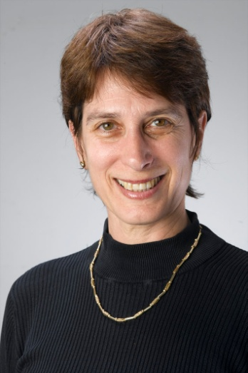
Anat Treister-Goren, Ph.D.,
International Coach Federation (ICF) accredited:

Master Certified Coach (MCC)
Certified Professional Co-Active Coach (CPCC)
Organizational Relationship System Coach Certified (ORSCC)

Dr. Anat Treister-Goren is the Owner and CEO of Lead, Out of the Box Leadership, Ltd.

Anat offers various coaching services. As an Executive Coach, her clients include hi-potentials, senior managers, leaders in key positions, and women in leadership positions. She leads training workshop offering leadership development, coach-approach skills and tools for managers and professionals. As an organizational relationship system coach, she works with teams, partnerships, family businesses, and more with a focus on the positivity and productivity of the relationships and the creation of collaborative leadership.

She is an international facilitator and trainer of world leading coach-training programs: for individual coach-training; The Coaches Training Institute, US and Europe, and for relationship-coach training; The Center for Right Relationships, US and Europe. She is also a subcontractor for Ken Blanchard (a world known provider of Executive Coaching). Finally, she is certified by Team Coaching International, US to administer the Team Diagnostics and its follow-up process. The models taught in these schools are based on latest findings in fields such as Emotional and Social Intelligences, Appreciative Inquiry, Positive Psychology, Change integration and management, System Work, Deep Democracy, Co-Active Coaching, and more.

Anat’s clients include banks, and venture capitals, hi-tech companies, companies from the retail industry, and individual managers and leaders from various fields including psychologists, academics, business owners, entrepreneurs, educational leaders, actors and musicians, engineers, finance managers, and many more. Anat’s clients are from Israel, Europe, Far-East and the US. She works with multi-cultural teams, and is a facilitator in various locations around the world including Spain, UK, Holland, Denmark, Germany, Sweden, Norway, France, Japan, and more.

Anat is committed to creating transformational processes with her clients, to professionalism, and to results. The individual and relationship coaching processes with clients often includes a focus on the following aspects: active listening to self, other and the system, conflict resolution, visioning, planning and strategy, creating accountability individually and in a team, value identification, meta-view skills, effective communication training (awareness of toxic communication and ways of recovery), acknowledgement skills, working with rank and privileges in systems, designing alliance tools, self management skills, leadership presence and projection, awareness of impact and many more.

Background:
In her past careers, Dr. Treister-Goren has been a lecturer and researcher in areas of Schizophrenic thought disorder, Linguistics and Conversational Analysis, Speech Pathology, Brain and Language, in major universities in the US and Israel for over ten years. She had also worked for several years in the private sector as a senior executive in hi-tech companies focused on speech recognition and artificial intelligence, serving in business development, R&D, and marketing positions. In her more distant past she was a professional singer and actress. Thus, she is well rounded in both managerial and leadership aspects as well as in emotional and social intelligence competencies and skills. Her services combine her education as a coach and facilitator with her expertese from past careers.

Academic degrees:
Ph.D.University of Washington, Neurolinguistics/Speech-Language Pathology, 1991.
M.Sc.University of Washington, Speech Science, 1989.
B.A.U of California Davis, Theoretical Linguistics, 1985.
Coach training education:
Certified Professional Co-Active Coach (CPCC), the Coaches Training Institute, USA, 2006-7.
Master Certified Coach, ICF accredited.
Organizational Relationship System Coach Certified (ORSCC), The Center for Right Relationship, USA., December 2008
Team Training Intensive Certification, Team Training International, USA, 2006.
Co-Active Leadership program, The Coaches Training Institute, USA, 2006.
Certified Personal and Business Coach, Telem College, Tel Aviv, 2004.

